Module 3 and 4 Assignment
Krishna M
Mepco Schlenk Engineering College, Sivakasi

- Simulate a small network with switches and multiple devices. Use ping to generate traffic and observe the MAC address table of the switch. Capture packets using Wireshark to analyze Ethernet frames and MAC addressing.

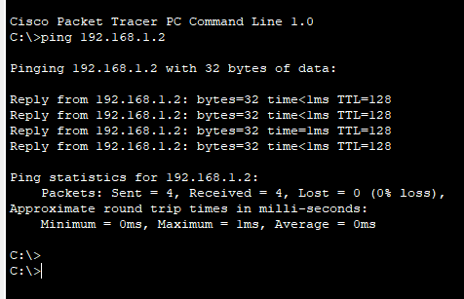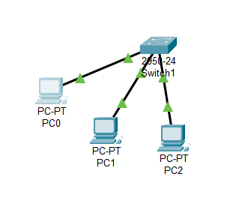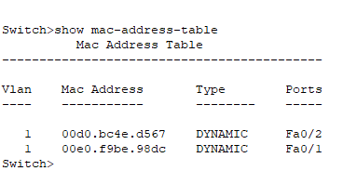

- Capture and analyze Ethernet frames using Wireshark. Inspect the structure of the frame, including destination and source MAC addresses, Ethertype, payload, and FCS. Use GNS3 or Packet Tracer to simulate network traffic.

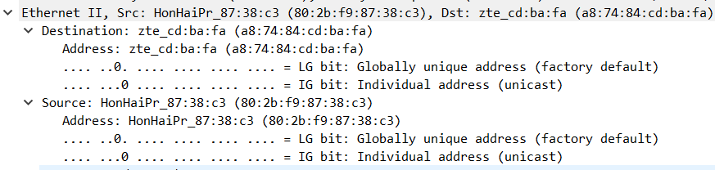
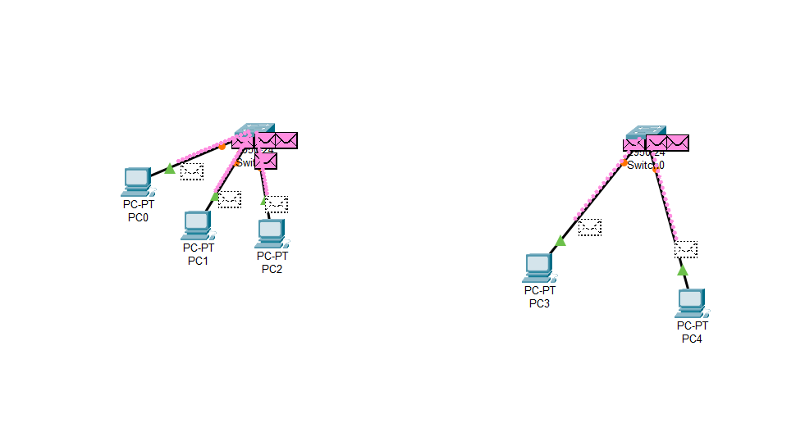
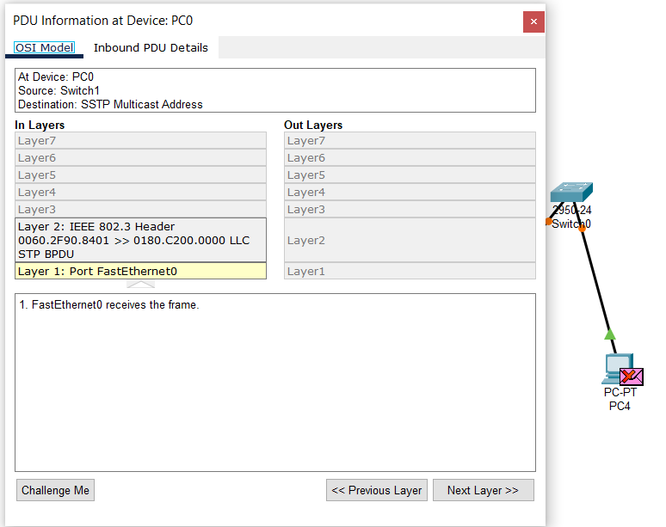

- Configure static IP addresses, modify MAC addresses, and verify network connectivity using ping and ifconfig commands.

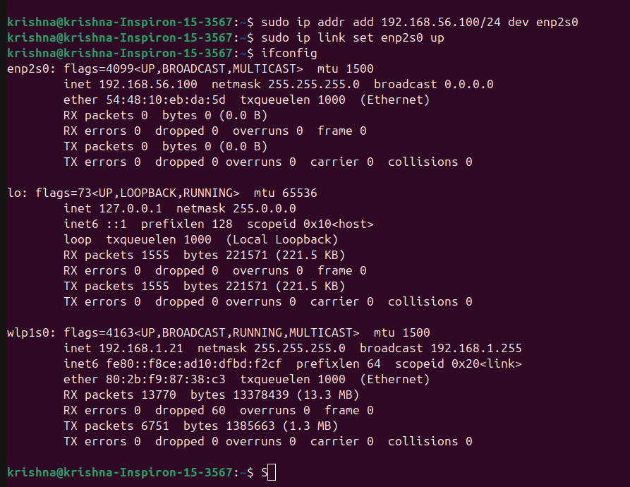

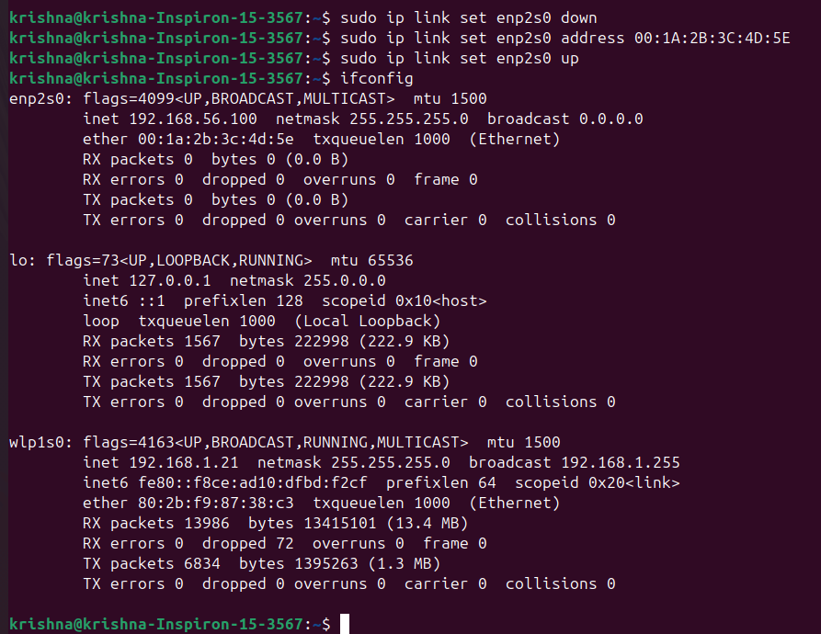

  - Create a simple LAN setup with two Linux machines connected via a switch. Ping from one machine to the other. If it fails, use ifconfig to ensure the IP addresses are configured correctly. Use traceroute to identify where the packets are being dropped if the ping fails. Research the Linux kemel's handling of Ethernet devices and network interfaces. Write a short report on how the Linux kernel supports Ethernet comnunication (referencing kemel.org documentation).

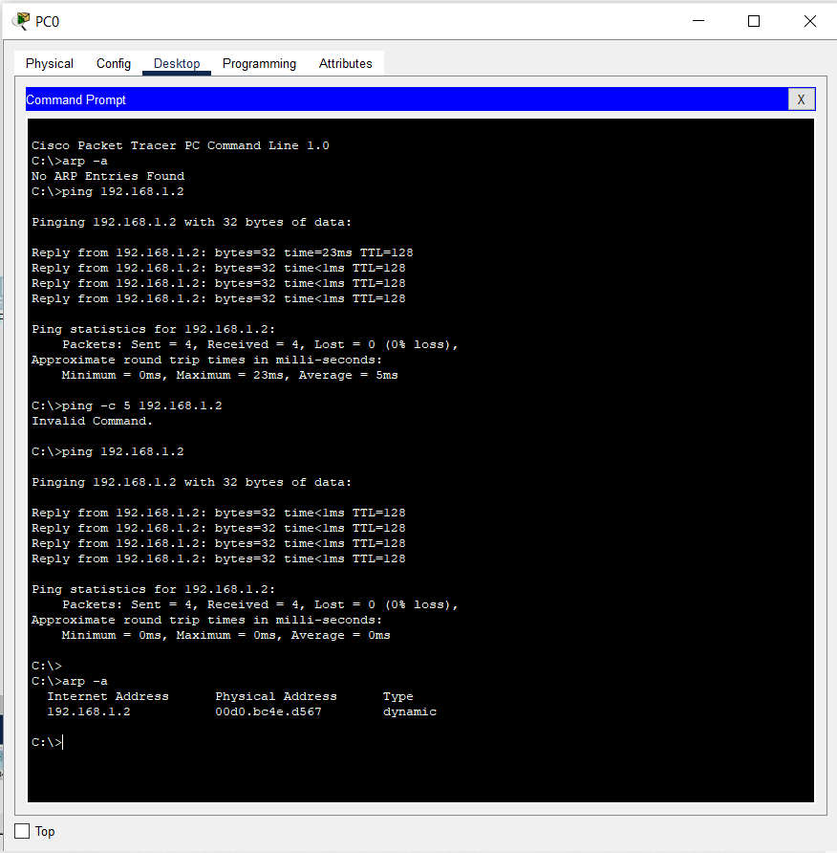
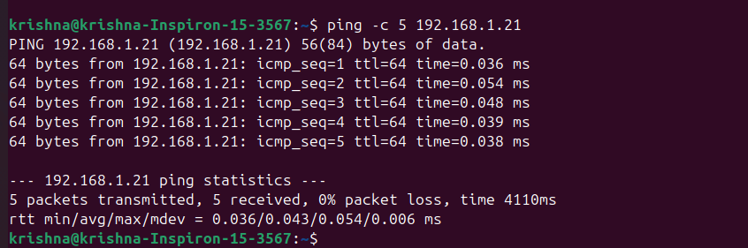

- Describe how you would configure a basic LAN interface using the ip command in Linux (kemel.org).

The Linux kernel supports Ethernet communication through its robust networking stack,
which manages network interfaces, packet transmission, and device drivers.
The netdev subsystem handles Ethernet devices, allowing seamless communication between software and hardware.
Ethernet device drivers enable network interface cards (NICs) to transmit and receive packets,
while the kernel’s network stack processes Ethernet frames using a layered approach—from
user space system calls (send(), recv()) to kernel space processing via the socket API, protocol stack (TCP/IP, UDP),
and network drivers. The kernel also supports virtual network interfaces (veth, bridge, bonding) alongside physical ones.
Network interfaces are managed using tools like ip and ifconfig, allowing users to configure and monitor connectivity.
The ip command is commonly used for configuration, where ip address add 192.168.1.10/24 dev eth0 assigns an IP, and ip link set eth0 up activates the interface.

- Use Linux to view the MAC address table of a switch (if using a Linux-based network switch). Use the bridge or ip link commands to inspect the MAC table and demonstrate a basic switch's operation. Submit your findings with explanations of what you observe.

